Plug-N-Harvest
Plug-n-play passive and active multi-modal energy Harvesting systems, circular economy by design, with high replicability for Self-sufficient Districts & Near-Zero Buildings
768735, H2020-EEB-2017

Meeting Agenda
Plug-N-Harvest Kick-off Meeting

Meeting Agenda Version: | v. 1.0
Document Identifier: | PnH_agenda_KickOff_meeting_v1.0
Preparation Date: | September 6, 2017
Document Status: | Final
Author(s): | Elias Kosmatopoulos (CERTH), Christos Ravanis (CERTH)
Dissemination Level: | PU - Public

Project funded by the European Community in the H2020 Framework Programme
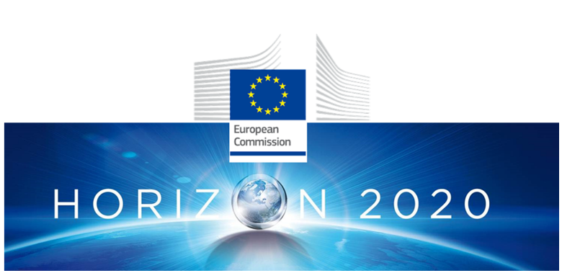
H20220-EEB-07-2017 - Integration of energy harvesting at building and district level

Meeting Agenda SUMMARY SHEET
Meeting Agenda Details
Type of Document: | Meeting Agenda
Document Reference #:
Title: | Plug-N-Harvest Kick-off Meeting
Version Number: | 1.0
Preparation Date: | September 6, 2017
Delivery Date: | Date
Author(s): | Elias Kosmatopoulos (CERTH), Christos Ravanis (CERTH)
Document Identifier: | PnH_agenda_KickOff_meeting_v1.0
Document Status: | Final
Dissemination Level: | PU - Public

Project Details
Project Acronym: | Plug-N-Harvest
Project Title: | Plug-n-play passive and active multi-modal energy Harvesting systems, circular economy by design, with high replicability for Self-sufficient Districts & Near-Zero Buildings
Project Number: | 768735
Call Identifier: | H2020-EEB-2017
Call Theme: | Integration of energy harvesting at building and district level
Project Coordinator: | Centre for Research and Technology Hellas (CERTH)
Participating Partners: | CERTH – Centre for Research and Technology Hellas – Greece  RWTH – RWTH Aachen University – Germany  CU - Cardiff University – United Kingdom  ALUMIL – Alumil Aluminium Industry S.A. – Greece  AIGUASOL – Sistems Avancats d’ Energia Solar Termica SCCL - AIGUASOL – Spain  ODINS – Odin Solutions S.L – Spain  SIE – Siemens SLR – Romania  ETRA – Etra Investigacion y Desarrollo S.A. – Spain  ET – Energy Transitions Limited – United Kingdom  EIG – Eco Intelligent Growth – Spain  AHC – Agencia de l’Habitatge de Catalunya – Spain  RWM – Region of Western Macedonia – Greece  CCC – County Council of the City and County of Cardiff – United Kingdom
Instrument:
Contract Start Date: | September 1, 2017
Duration: | 51 Months

Meeting Agenda : Short Description
Keywords:

Meeting Agenda : Revision History
Version: | Date: | Status: | Comments
0.5 | 31/8/2017 | Draft | Structure and inputs by Elias Kosmatopoulos and Christos Ravanis (CERTH)
0.6 | 3/9/2017 | Draft | Inputs and suggestions from ETL
1.0 | 6/9/2017 | Final | Final version by CERTH

Copyright notices
© 2017 Plug-N-Harvest Consortium Partners. All rights reserved. Plug-N-Harvest is a H2020 Project supported by the European Commission under contract #768735. For more information on the project, its partners, and contributors please see http://www.plug-n-harvest.eu/. You are permitted to copy and distribute verbatim copies of this document, containing this copyright notice, but modifying this document is not allowed. All contents are reserved by default and may not be disclosed to third parties without the written consent of the Plug-N-Harvest partners, except as mandated by the European Commission contract, for reviewing and dissemination purposes. All trademarks and other rights on third party products mentioned in this document are acknowledged and owned by the respective holders. The information contained in this document represents the views of Plug-N-Harvest members as of the date they are published. The Plug-N-Harvest consortium does not guarantee that any information contained herein is error-free, or up to date, nor makes warranties, express, implied, or statutory, by publishing this document.
Table of Contents

1 Overview 1
2 Agenda 1

Plug-N-Harvest: Kick-off Meeting
21-22 September 2017
E.ON Energy Research Center, Aachen

Overview
First Day (21 September 2017): Kick-off Meeting
Second Day (22 September 2017): Kick-off Meeting

Agenda
21st September 2017 – E.ON Energy Research Center:
10 Mathieustrasse str., 52074, Aachen, Germany
Check the map for the exact location!

Time | Agenda Item | Moderator
09:00 – 10:30 | Opening – Welcome  - List of attendees, 5-min Introductions  - Approval of agenda  - Group photo | CERTH
10:30 – 11:30 | Project Overview & Management  - Project overview  - Organizational / Administrative Matters  - Plug-N-Harvest’s website | CERTH
11:30 – 11:45 | Coffee Break
11:45 – 13:45 | The PLUG-N-HARVEST ADBE System  - ADBE Technical requirements  - Dynamic energy process engineering platform | RWTH  CERTH  ALUMIL
13:45 – 14:45 | Lunch Break
14:45 – 17:45 | The PLUG-N-HARVEST Control and Management at Building and District Level  - IMCS  - OEMS  - Security | CERTH  ETRA  SIEMENS  OdinS
17:45 – 18:00 | Misc. / AOB | CERTH

22nd September 2017 – E.ON Energy Research Center:
10 Mathieustrasse str., 52074, Aachen, Germany
Check the map for the exact location!

Time | Agenda Item | Moderator
09:00 – 09:15 | Opening – Welcome  - List of attendees  - Approval of agenda | CERTH
09:15 – 11:15 | Requirements Analysis and Engineering  - Pilots  - End Users  - Use cases requirements and analysis  - Active-façade CFD simulation and optimization  - Architectural design, functional & technical specifications | AIGUASOL  CU  CERTH  RWTH
11:15 – 11:45 | British pilot site description | CCC
11:45 – 12:15 | Coffee Break
12:15 – 12:45 | German pilot site description | RWTH
12:45 – 13:15 | Spanish pilot site description | AHC
13:15 – 13:45 | Greek pilot site description | RWM
13:45 – 14:45 | Lunch Break
14:45 – 16:45 | Plug-N-Harvest Business Model and Exploitation Plan  - Design delimitants, Conditioners & Material Database  - Circular Economy Solutions (Evaluation, Impact Assessment)  - Life Cycle Costing tool | AIGUASOL  EIG  CERTH
16:45 – 17:30 | Dissemination & Communication Plans & Standardization | CERTH  ALUMIL
17:30 – 18:00 | Conclusions / Misc. / AOB | CERTH

